Talking about climate change is never easy. The debate is fraught with uncertainty, highly politicised and suffused with a tendency towards moralising judgements on the part of many participants. In [my experience](http://www.theguardian.com/commentisfree/2015/mar/12/climate-change-reclaim-debate-political-extremes), people shoe-horn their visions of the future onto climate change, so anti-capitalists tend to use global warming as a reason to continue to oppose capitalism, while free-marketeers tend to be sceptical about the science because they don't like the idea of government intrusion into markets to regulate carbon emissions.

But what if there were a way to represent peoples' different preferences with real-world numbers, and see what the impact would be on the planet? There is - it's called the Global Calculator: free online, open-source, and with an easy to navigate interface where every user can select from a wide variety of different options on everything from dietary choices to transport patterns and see how it stacks up in terms of carbon emissions and the resulting eventual global temperature.

In order to introduce the tool, which was developed by a team assembled by Professor David MacKay (of '[Sustainable Energy Without the Hot Air](http://www.withouthotair.com/)' fame), I've plotted out my own numbers, which I will run through below. These are roughly an 'ecomodernist' worldview: I want to see a planet where everyone who chooses to can access modern lifestyles, without such an enormous rise in consumption that we end up frying the planet. Is this even possible? [My pathway](http://tool.globalcalculator.org/globcalc.html?levers=231133333111t232qqqpq13313f11322324432334111111f32211111111/dashboard/en) shows that it is:

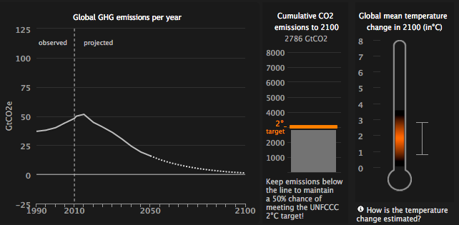

The graph shows an early peak in greenhouse gas emissions, and a reduction to below zero by 2100. This results in cumulative emissions being below the level necessary to keep the planet's temperature from rising above 2 degrees C, as represented (with shading to show uncertainty) by the thermometer on the right.

How did I do it? By making all kinds of different selections from the multiple choices set out below:

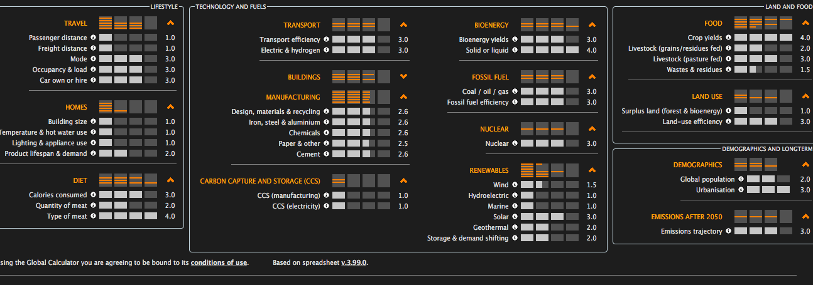

The best way to get a sense of how the Global Calculator works is to have a play with it yourself. My pathway is just one of numerous different alternatives. In general level 1 selections allow for increases in consumption and comfort, while level 4 selections require a tremendous amount of effort. This applies to both the demand and supply sides of the equation.

For example, I've selected mostly level 1s on travel, buildings, air conditioning/heating and so on. This is to reflect the fact that most of the world's population still under-consumes in these areas, so to allow room for growth. (click on the little 'i's next to each option to see what it means) So I'm allowing a 45% increase in global travel by 2050, for example. I'm also allowing [every household in the world](http://tool.globalcalculator.org/gc-lever-description-v23.html?id=12/en) to have a refrigerator and other appliances almost at the level of the USA today.

That means a lot more energy use, and this energy needs to be low-carbon. So I have [level 3 solar generation](http://tool.globalcalculator.org/gc-lever-description-v23.html?id=30/en), a massive 4,100 gigawatts of solar capacity by 2050 (up from [around 200 GW](http://cleantechnica.com/2015/04/02/global-solar-pv-capacity-ends-2014-177-gw/) today). And I have [about a tripling](http://tool.globalcalculator.org/gc-lever-description-v23.html?id=26/en) of nuclear power capacity worldwide from today (also level 3) to add to the zero-carbon power produced from solar and wind.

But actually energy (especially electricity) is only a part of the picture. Just as important are my selections for global diets, agriculture and land use. And these issues pertain directly to the mission of the Cornell Alliance for Science. For example, I've selected level 4 on crop yields:

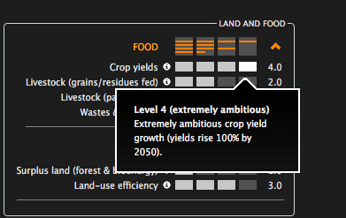

This means that we need to make a great effort to keep on improving yields of major food crops, to reach 100% increase by 2050, either using genetics or other agronomic approaches (or more likely both). Why is this important? Because it can then spare farmland from being ploughed up, and protect the rainforests. Even better, by also constraining the amount of meat people eat globally (meat, especially beef, is a very inefficient way of converting crop biomass into human food energy) I can even spare land for reforestation.

So while I allow for everyone to have a healthy calorific intake, global average meat consumption by 2050 would not reach levels in Europe and the US, which are too high currently. I'm under no illusions: this would require a huge lifestyle change for many people in rich countries, but it would be healthier for them and the planet. This represents a [level 2 choice](http://tool.globalcalculator.org/gc-lever-description-v23.html?id=34/en), so the global average would be 220kcal/meat per person per day (the USA is currently 350).

Speaking of reforestation, this combination of more productive cropland, less meat and a very low use of bioenergy (so forget biofuels, basically, which are a big waste of land and a threat to ecosystems generally) here's what I can do with forest land (click 'land and food' at the top to get this display):

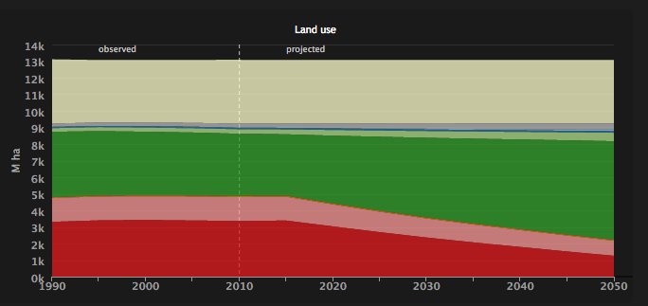

You will see a dramatic expansion of global natural forest land - basically rewilding - starting from pretty much the current day.

So what happens if we revert to high meat eating, have extensive grass-fed beef animals and low-yield agriculture (basically organic farming planet-wide with high meat consumption)? I get this warning message:

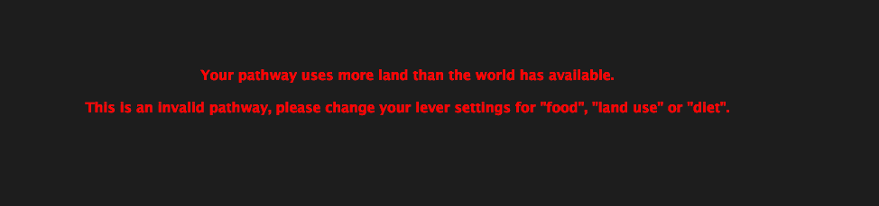

And even if I moderate these choices a little I still get this:

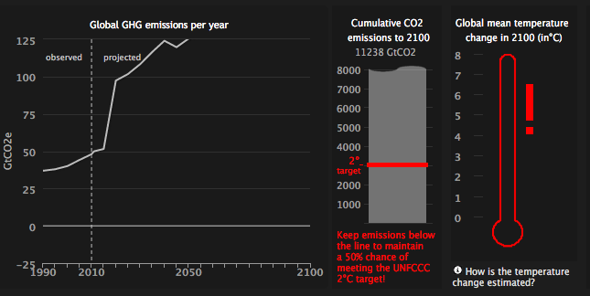

That's right: unless we make farming much more efficient and restrain the increase in meat consumption, emissions go through the roof. This is an interesting challenge for the agro-ecology movement - the explanatory notes for the calculator's section on crop yields have this to say on the issue of organic farming:

"To represent a move towards an organic farming system in the Global Calculator, crop yields are likely to be lower than industrialised systems, therefore between Level 1 to level 2 for crop yields would be most appropriate. On a global average, organic crop yields tend to be lower than those of industrialised systems. This would likely result in more land being required to grow crops compared to industrialised systems, and hence could result in deforestation to make way for more agricultural land unless offset to some extent by a concurrent increase in land use efficiency."

[Friends of the Earth's pathway](http://tool.globalcalculator.org/globcalc.html?levers=32334434433444444333314411212324myw121l121111113f2211111111/dashboard/en) does work however - with low crop yields and not much improvement in farming efficiency, so basically taking an organic approach. But it does that by making heroic assumptions in my view about meat-eating and calorific intake generally: global diets would be heading towards the average in India by 2050 (basically vegetarian). Oh, and there's no nuclear power, and lots of renewables, as you might expect.

However, I can't say Friends of the Earth is wrong - their pathway adds up to less than 2C global warming, and that's fine by me. This is the great value of the Global Calculator - it helps us to tease out the assumptions and choices underlying our views of the future and our different ideas about how best to mitigate climate change. There are lots of example pathways: you can scroll through them all using this drop-down menu:

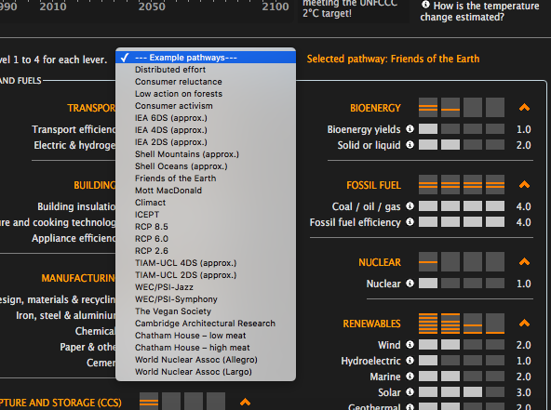

But most importantly - come up with your own pathway, one which you feel is both realistic and reflects the world you want to live in. Just make sure it keeps the planet's temperature from rising above 2 degrees!